**Stage 1 – “This shit's chess, it ain't checkers.”**

**RULES:** Practical Shooting Handbook, Latest Edition **COURSE DESIGNER:** Ike Starnes

|  |
| --- |
| **START POSITION: See written stage briefings.** |

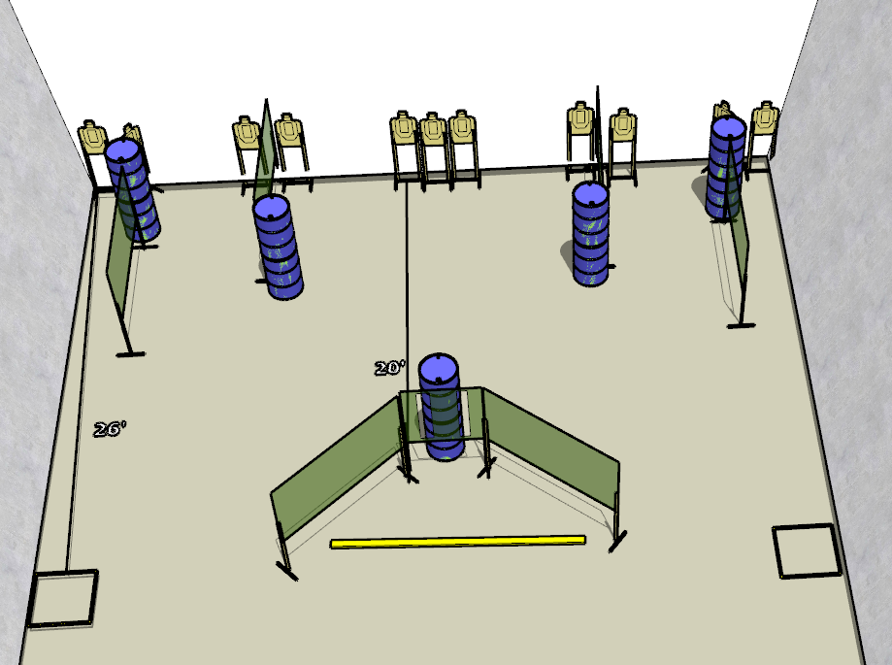

**Written Stage Briefings:**

**Stage 1 – “This shit's chess, it ain't checkers.” -** is a 22-round, 110 point, Comstock Long Course. There are 11 cardboard targets. The best 2 hits per cardboard target will be scored.   
**Handgun start position** Both feet inside left shooting box, wrists below belt. The handgun is **loaded** and holstered.

**PCC start position** Both feet inside left shooting box. PCC is **loaded** with buttstock on belt.

On the audible start signal, engage targets from within the shooting area.

**Stage 2 – “It's No Fun When The Rabbit Has The Gun, Is It?” -** is a 22-round, 110 point, Comstock Long Course. There are 11 cardboard targets. The best 2 hits per cardboard target will be scored.   
**Handgun start position** Both feet inside right shooting box, wrists below belt. The handgun is **loaded** and holstered.

**PCC start position** Both feet inside right shooting box. PCC is **loaded** with buttstock on belt.

On the audible start signal, engage targets from within the shooting area.

**Stage 3 – “King Kong ain't got shit on me!” -** is a 22-round, 110 point, Comstock Long Course. There are 11 cardboard targets. The best 2 hits per cardboard target will be scored.   
**Start position** Seated in chair, hands on knees. Firearm unloaded and placed un-propped on the barrel.

On the audible start signal, engage targets from within the shooting area.